MODULE 4 – INTRODUCTION TO DBMS

LAB EXERCISES

13. SQL Stored Procedure
Lab 1.
Write a stored procedure to retrieve all employees from the employees table based on department.
Ans.
1. DELIMITER //

CREATE PROCEDURE getemployeesbydepartment(IN dept int)

BEGIN

SELECT * FROM employees WHERE dept_id = dept;

END //

DELIMITER ;
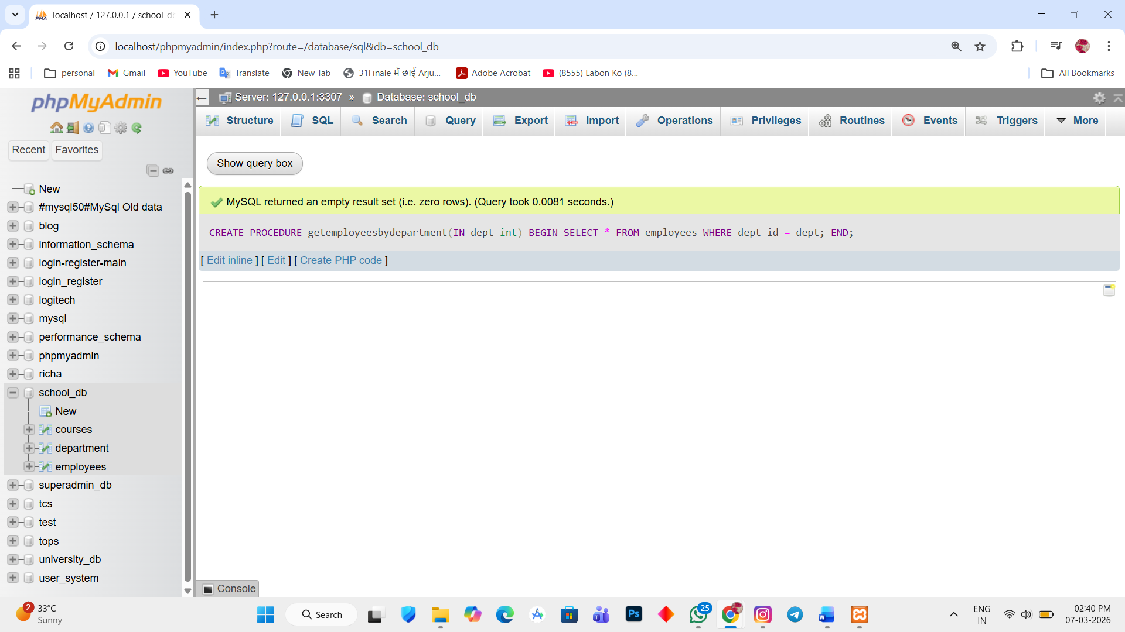

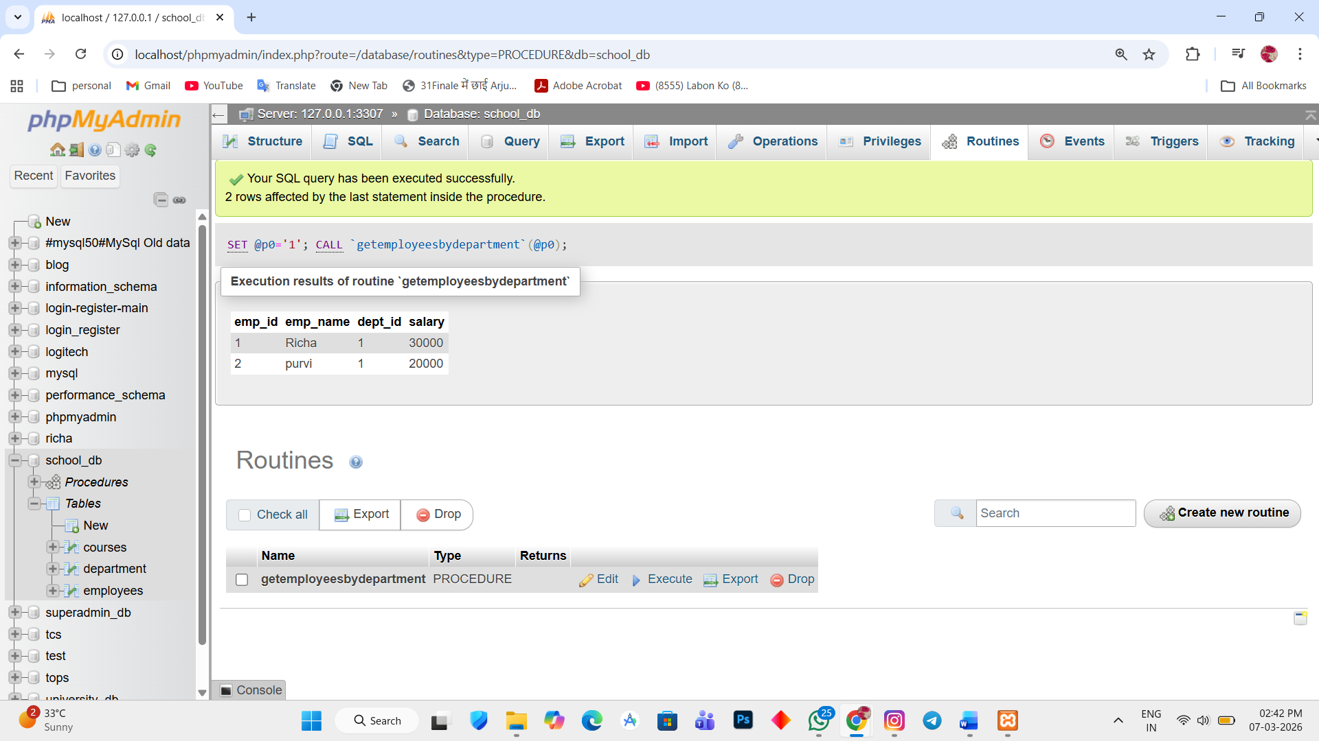

Lab 2.
Write a stored procedure that accept course_id as input and returns the course details.
Ans.
1. DELIMITER //

CREATE PROCEDURE getcoursedetail(IN cid int)

BEGIN

SELECT * FROM courses WHERE course_id = cid;

END //

DELIMITER ;

